Collaborative consumption and peer-to-peer collaboration

Daniel Christian Wahl
Following
Aug 17, 2017 · 7 min read
The field of collaborative consumption is one of the areas of social innovation that most excites me. Rachel Botsman and Roo Rogers (2011) offer an introduction to this rapidly evolving approach to participatory culture change in What’s Mine is Yours.
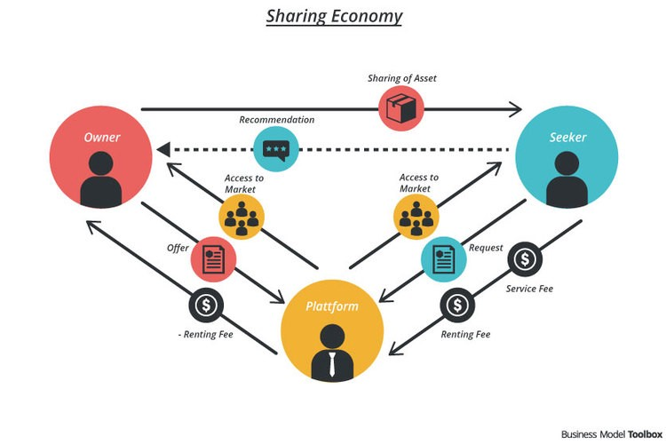
The Sharing Economy (Source)
Fundamentally there are two different ways to engage with collaborative consumption, either as a ‘peer-provider’ offering assets to borrow, rent or share, or as a ‘peer-user’ renting, borrowing or sharing the assets offered by peer-providers (p.70).
Swap trading, time banks, local exchange trading systems (LETS), bartering, social lending, peer-to-peer currencies, tool exchanges, land share, clothing swaps, toy sharing, shared workspaces, co-housing, co-working, CouchSurfing, car sharing, crowdfunding, bike sharing, ride sharing, food co-ops, walking school buses, shared microcrèches, peer-to-peer rental — the list goes on — are all examples of Collaborative Consumption. Some of these may be familiar already, some not, but all are experiencing a significant growth surge. Although these examples vary in scale, maturity and purpose, they can be organized into three systems — product service systems, redistribution markets and collaborative lifestyles. Botsman & Rogers (2011: 71)
One of the underlying shifts in worldview and thinking is that from needing to own to preferring simply to have access to shared goods and services. A ‘product service system’ (PSS) allows people to receive the benefits of a product without having to actually own it themselves. Rachel Botsman on collaborative consumption
Car sharing, co-working spaces or launderettes, for example, allow people to use products owned by service providers for a usage fee. Another kind of PSS enables people to share or rent privately owned items via a social P2P (peer-to-peer) market place, for example companies like Zilok or Erento. The global-local arts and crafts market place Etsy allows small scale artisan producers anywhere to have access to a global market; while redistribution markets like eBay and Around Again enable goods no longer needed by their original owner to be reused elsewhere.
‘Redistribution markets’ are online market places enabling goods no longer needed by their original owner to be reused elsewhere. Social enterprises like Freecycle and Around Again have created a marketplace based on entirely free exchanges; Barterquest allows people to sell no longer needed goods and earn points for future purchases on the system; eBay has built a global online marketplace where people can trade their possessions for money; while Gumtree and Craigslist offer a hybrid of these options along with job listings, community services and more.
There are many other online marketplaces that have focused on specific items such as books (readitswapit), baby clothes (tradingcradles), fashion items (swapstyle) and clothes (threadup), toys and baby items (babyswaporshop). The way that redistribution markets enable people to reuse existing products and convert no longer needed products into income has significant environmental, social and economic benefits. It generates extra income, reduces material consumption and waste, and in many cases helps to create human connection and even community.
The third type of collaborative consumption identified by Botsman and Rogers, ‘collaborative lifestyles’, extends the P2P exchange from physical goods to the sharing of time, skills, space and money. Both PSS and ‘redistribution markets’ are also enablers of ‘collaborative lifestyles’, which make use of hybrid systems of all three types of collaborative consumption. ‘Collaborative lifestyles’ generate the additional benefit of exchanges on a local or regional scale leading to human connections beyond the virtual platform by matching spare capacity with unmet needs.
For examples, networks of local collaborators who share a common working space (impacthubs) are linked into global skill and knowledge sharing networks. The global network Hubculture connects these innovators, social entrepreneurs and cultural creatives, enabling them to collaborate and share knowledge through the use of their own digital currency, the Ven. The Landshare network in the UK, Australia and Canada connects people with underused land to people who want to garden or farm.
Similarly, Edinburghgardenpartners matches keen gardeners or people who want to grow their own vegetables with garden owners in the city. Neighborhood Fruit has mapped more than 10,000 fruit trees and vegetable plots across the USA on a mobile app and website to enable people to find and share the fruits, nuts and vegetables growing in their neighbourhood without the exchange of money. The global online parking market place ParkatmyHouse offers individuals and businesses the opportunity to rent out unused parking spaces to those who are in need of them.
In 1999, a group of successful Silicon Valley entrepreneurs decided to offer their unique skill sets to help the worthwhile causes of non-profit organizations. The main motivation was to find deeper meaning in their work and skills than they gained from simply working in the for-profit sector. Nipun Mehta was one of the initiators of ‘CharityFocus’, since renamed as ServiceSpace — an incubator of projects in the gift economy.
Nipun coined the term ‘giftivism — the practice of radically generous acts that change the world’. Nipun believes that four key societal shifts can transform our culture: from consumption to contribution, transaction to trust, isolation to community, and scarcity to abundance” (Metha, TEDxBerkeley 2012).
Design for Generosity by Nipun Mehta
As an all-volunteer organization that leverages technology to inspire greater volunteerism, ServiceSpace aims to help people to take part in these social shifts. In 15 years it has grown to a global network of 400,000 people who volunteer their skills and time to help others. Among the projects that have been incubated in, or supported by, this network are:
DailyGood — a website that promotes uplifting news from around the world;
Karmatube — a site that allows people to access and stream inspirational videos;
CFtools — helps charities to create custom websites at no cost;
Work & Conversations — facilitates learning about and from artists;
ProPoor — an internet portal offering information about resources and news relevant to development work in South Asia;
PledgePage — a free online platform that allows people to showcase their favourite causes and fundraise for them;
MovedByLove — a network to promote radical generosity projects in India;
KarmaKitchen — a volunteer-run restaurant in Berkeley, California, where people gift for the meals of those who come after them but do not have to pay for what they ate themselves (The team has served more than 24,000 meals since 2007 and there are now Karma Kitchens operating in Washington, DC and Chicago as well.);
AwaKin is a web forum that helps people access inspirational tools for personal development and connects them to a community of kindred spirits; and
KindSpring aims to promote a global movement of kindness through sharing stories and ideas like the ‘smile card’ which people can leave behind for the person they have just helped anonymously to invite them to pay the gift forward and consider gifting or helping others anonymously.
All these diverse projects created by ServiceSpace volunteers are excellent examples of the power of transformative social innovation and the shift towards a regenerative culture.
Many more inspiring examples of such P2P collaboration, open innovation and P2P technology development have been collected and explained through the excellent work of Michel Bauwens and the ‘p2p Foundation’. The foundation’s wiki-site is a treasure trove of inspiration on how P2P initiatives can catalyse the transition towards regenerative cultures. Among many case studies the site explores P2P civil society approaches, P2P market approaches, and P2P stateapproaches.
In 2013 Michel Bauwens worked with the FLOK society project aiming to create a commons-based P2P economy in Ecuador. The project is part of Ecuador’s national ‘good life plan’. Transformative innovation and culture change based on social innovation, P2P collaboration and a reclaiming of the commons is well under way. We should follow such Horizon 3 experiments with interest. Michel Bauwens on Four Scenarios for the Collaborative Economy
[This is an excerpt of a subchapter from Designing Regenerative Cultures, published by Triarchy Press, 2016. Note: the excerpt has been altered from the version that is now in the printed and e-copy book. The editor made me cut out a fair amount of the detailed examples and I am taken the opportunity here to share the more original version of this sub-chapter.]
Daniel Christian Wahl works internationally as a consultant and educator in regenerative development, whole systems design, and transformative innovation. He holds degrees in biology (Univ. of Edinburgh), and holistic science (Schumacher College), and his 2006 doctoral thesis (Univ. of Dundee) was on Design for Human and Planetary Health.
He was director of Findhorn College between 2007 and 2010, and is a member of the International Futures Forum since 2009 and Gaia Education since 2007. He has collaborated with UNITAR and UNESCO, many large NGOs, and as a consultant he has worked with companies such as Camper, Ecover and Lush, as well as, with UK Foresight (with Decision Integrity Ltd) and the Commonwealth Secretariat (with Cloudburst Foundation).
Daniel is a fellow of the RSA, a Findhorn Foundation Fellow, on the advisory council of the Ojai Foundation and the research group of the Global Ecovillage Network. He is co-founder of Biomimicry Iberia (2012), and has been collaborating with ‘SmartUIB’ at the University of the Balearic Islands since 2014. Daniel currently also works part-time as Gaia Education’s head of innovation and programme design.
His first book Designing Regenerative Cultures was published in 2016 by Triarchy Press and has already reached international acclaim.

